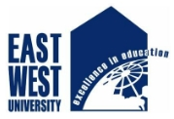

Department of Civil Engineering
East West University

Notice
Field Trip 2022
Biswas Ceramics & Auto Bricks
The Department of Civil Engineering is going to arrange a field trip on 1st September 2022 at Biwas Ceramics & Auto Bricks, Saoghat, Bhulta, Rupganj, Narayanganj. Student of Civil Engineering Department who did not participate in any of the previously arranged field trip by the department are eligible to participate in this field trip. Further details of the Field trip can be found below:

Date: 1st September 2022 (Thursday)
Seat Capacity: 28 (First come first served)
Registration Fee: 200 Taka
Registration Date: 25th August – 31st August 2022
Registration: Contact Md. Al Muktadir, Lab officer (EM Lab)

____________________
The Chairperson
Department of Civil Engineering
East West University

